|  |  |
| --- | --- |
| **Practicum Case** |  |
| CPEN6098 | CPEN6108 | CPEN6109  Computer Networks |
| **Computer Engineering** | **O1-CPEN6098-CP01** |
| ***Valid on*** *Even Semester Year 2018/2019* | **Revision 00** |

## Learning Outcomes

* Describe basic structures of network
* Explain basic concepts of network

## Topic

* Session 08 - Routing Techniques - Dynamic Routing

## Sub Topics

* OSPF
* EIGRP
* RIP

## Soal

*Case*

**Dynamic Routing**, is a routing techniques on networking to provides the optimal routing traffic data and enabling the routers to choose own path on the network to reach the routing destination. Dynamic routing make the large network routing easily to configures and optimize the routes cost. There are the dynamic routing algorithms:

1. **OSPF** (**Open Shortest Path First**), is a routing protocol that used to find the best path for sending packets through the network and OSPF using **Interior Gateway Protocol** (**IGP**) and shortest path first based on Djikstra’s algorithm for routing.
2. **EIGRP** (**Enhanced Interior Gateway Routing Protocol**), is a routing protocol that each router shared their route information to other routers and also known as an advanced distance vector routing protocol. This routing protocol using **DUAL** (**Diffusing Update Algorithm**) algorithm, that used to obtain loop freedom at each input or output of router computation and this allow all routers in topology to synchronize routing information.
3. **RIP** (**Routing Information Protocol**), is a standard IGP protocol for LAN and the oldest distance vector routing protocol that used the hop count for routing. The maximum numbers of hop for RIP is 15 as limit for the network size that RIP support.

**Exercises**:

Please see at the picture below!

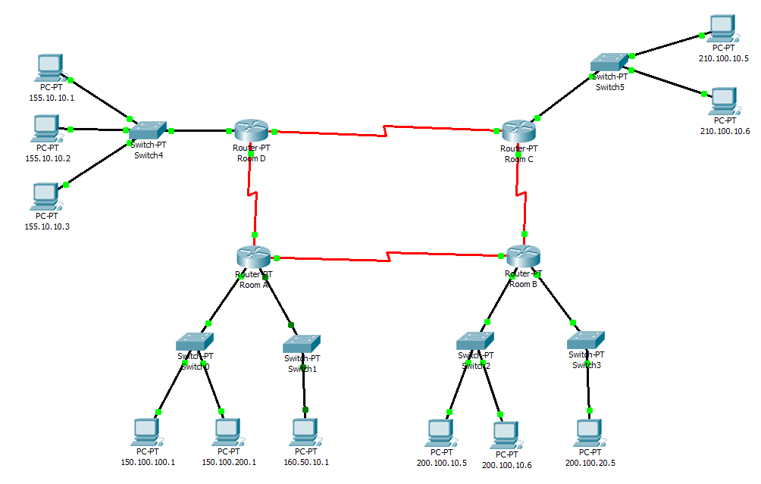

Create a network as a picture and do the **dynamic routing configuration** on each Cisco router using **all of three algorithms** (**OSPF**, **EIGRP**, and **RIP**) until each computer on every network can **communcating** each others! Analyze all routing table on each router and each algorithm!

**If you don’t understand, please ask to your assistant!**